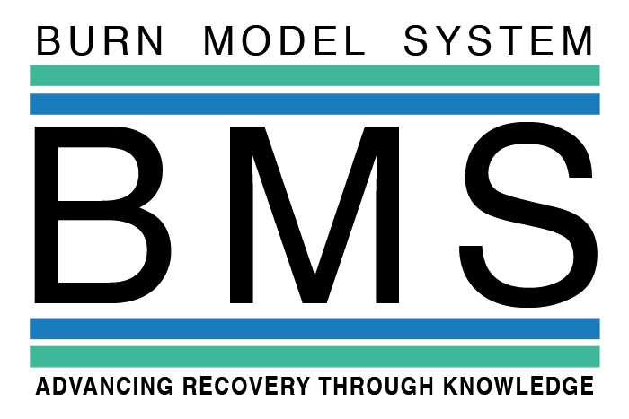
What researchers have learned from participants like you:
National Database Update
April 2016
Who is in our study?
- Almost 4,000 adults (ages 18 to 94) and over 2,000 children have provided information.
- People from all over the United States and other countries, such as Mexico take part in our study.
- Most people in our study were injured by fire/flame, but there are many other types of injuries as well.
- The average total body surface area burned for people in our study varies, and has ranged from 16% to 48% since 1994.
Scientists and doctors have learned more about burn injuries, thanks to people like you. As a research participant, your input about burn injury helps to improve the care for many burn survivors in the future.

Burn Model System Update
The Burn Model System (BMS) is a group of hospitals that receives money from the Federal Government to study the long term outcomes of people with burn injuries. We are doctors and researchers interested in using information from burn survivors to advance science and medical care. Our main project is collecting data from participants at several time points after their injury, including information about physical and emotional health. This information helps us develop programs that assist burn survivors in their recovery. We have also been studying exercise, and pain and itch management.

What have we learned?
Using the information from survey participants we have learned that:
- Itching can be a problem for burn survivors years after the injury, but generally decreases over time.
- Exercise can help to improve health after a burn injury and plays a role in keeping skin from becoming tight.
- Returning to work following injury is important in improving overall quality of life for burn survivors.

What else do we do?
The BMS develops fact sheets to provide more information about living with a burn injury. These fact sheets can be found at www.msktc.org. We also:
- Work with the Phoenix Society for Burn Survivors and their SOAR program
- Participate in burn survivor support groups
- Present information learned from the BMS surveys at national and international conferences
- Gather doctors, researchers, and burn survivors for a State of Burn Science meeting

Reminders about the research process:
Our researchers will give you a survey to complete. The survey asks questions about your life and your health. The survey can be done in person, over the phone, or by mail—whichever works best for you. You may skip questions you do not wish to answer.

What happens with your information?
We use your information for study purposes only and keep your information confidential and secure at all times. Based on federal laws, we can’t access your medical records without your permission. Your participation in this study is voluntary and doesn’t affect your health insurance coverage or medical care in any way.

How to contact us?
If you are interested in participating or need more information about the study, please contact us at: burndata@uw.edu

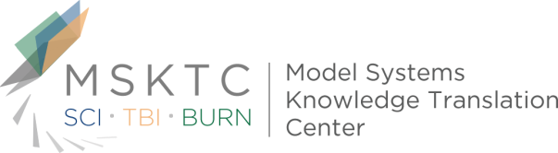
Thank you for being a part of our research!

