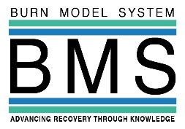
Share Your Experiences With Burn Injury:
Become a Research Participant!

You can make a difference. Get involved!
Today’s medical care is possible because of people like you. As a research participant, your input about burn injury will help to improve future care for thousands of burn survivors. Your experiences are critical to this study.
What have past participants said about our research?
- “I participated to help other burn patients.”
- “I would tell other burn survivors considering participation in the study to participate. You learn a lot of things you may not have known before.”
- “I chose to participate to help develop better treatments for patients.”
- “My son wanted to participate to help other children in his situation.”

What is the Burn Model System?
The Burn Model System (BMS) is a group of hospitals that receives money from the Federal Government. This money helps to fund research on improving the health and quality of life for people with burn injury.

Who should join the study?
If you are a burn survivor, we want to hear from you. We are interested in all kinds of experiences. No burn is too small. We can learn valuable information from people who’ve healed easily and from those who continue to deal with long-term issues. Please ask your burn doctor if you are a good fit for this study.

Why should I join the study?
Your input will help patients, nurses, and doctors make more informed decisions about treatment in the hospital and after discharge. For example, we can turn your input into fact sheets that deliver important information about a variety of burn injury topics, such as itch, employment, and returning to school after a burn injury.

How do I share my experiences?
Our researchers will give you a survey to complete. The survey asks questions about your life and your health. The survey can be done in person, over the phone, or by mail—whichever works best for you. You don’t have to answer every question. We’ll ask you to complete the survey a few times: 6 months, 1 year, and 2 years after your burn injury. After that, we’ll ask you to complete the survey every 5 years.

What happens to my information?
We’ll use your information for study purposes only. We’ll keep your information confidential and secure at all times. Based on federal laws, we can’t access your medical records without your permission. Your participation in this study won’t affect your health insurance coverage or any health care services you may need.

What if I want to stop being in the study?
Taking part in the study is your choice. You can stop at any time.

How to contact us?
If you are interested in participating or need more information about the study, please contact us at: burndata@uw.edu

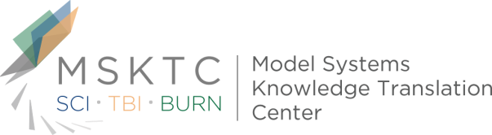
Thank you for considering being a part of our research!

